Design Specification
Servo System

CONTENTS
1. Introduction 5
1.1 Purpose 5
1.2 Scope 5
1.3 Definitions 5
2. Design Overview 6
3. Servo FSM5 8
3.1 EIB Power Management Design 9
3.2 Supervision Design 13
3.3 Synchronization Design 15
4. Servo IAB 16
4.1 Feedback Data Process Design 18
4.2 Path Planner Design 21
4.3 Interpolation Design 26
4.4 Servo Algorithm Design 28
5. Channels 34
5.1 Ring Master Driver Design 35
5.2 EMAC Driver Design 35
6. Scheduler 36
7. Calculation Units 37
8. References 39
9. Revision 40

Figures
Fig 1 Design of System Structure 6
Fig 2 Design of Servo FSM5 8
Fig 3 Data Structure of EIBPowerControl 9
Fig 4 Activity of TurnOffPower 10
Fig 5 Activity of TurnOnPower 11
Fig 6 Activity of IsEIBPowerReady 12
Fig 7 Data Structure of Supervision 13
Fig 8 Activity of Supervision 14
Fig 9 Design of Servo IAB 16
Fig 10 Data Structure of Feedback Data Process 18
Fig 11 Activity of Execution 19
Fig 12 Activity of Position Calculation 19
Fig 13 Activity of Speed Calculation 20
Fig 14 Activity of Angle Calculation 20
Fig 15 Data Structure of Path Planner 21
Fig 16 Activity of PathParaCalculation in PathGenerator 22
Fig 17 Activity of Execution in PathGenerator 23
Fig 18 Activity of PathParaCalculation in PathPlanner 24
Fig 19 Activity of Execution in PathPlanner 25
Fig 20 Data Structure of Interpolation 26
Fig 21 Activity of Interpolation 27
Fig 22 Data Structure of PID Controller 29
Fig 23 Activity of Servo Algorithm 30
Fig 24 Activity of PI Algorithm 31
Fig 25 Activity of Filter Process 32
Fig 26 Activity of Limit Process 33
Fig 27 Activities of Calculation Units 37

Tables

Introduction

1.1 Purpose
The paper specifies the design of servo system.

1.2 Scope
Design specification of servo system
The design follows standard state-machine-based template

1.3 Definitions
Word | Description

Design Overview
The system structure is designed as following:
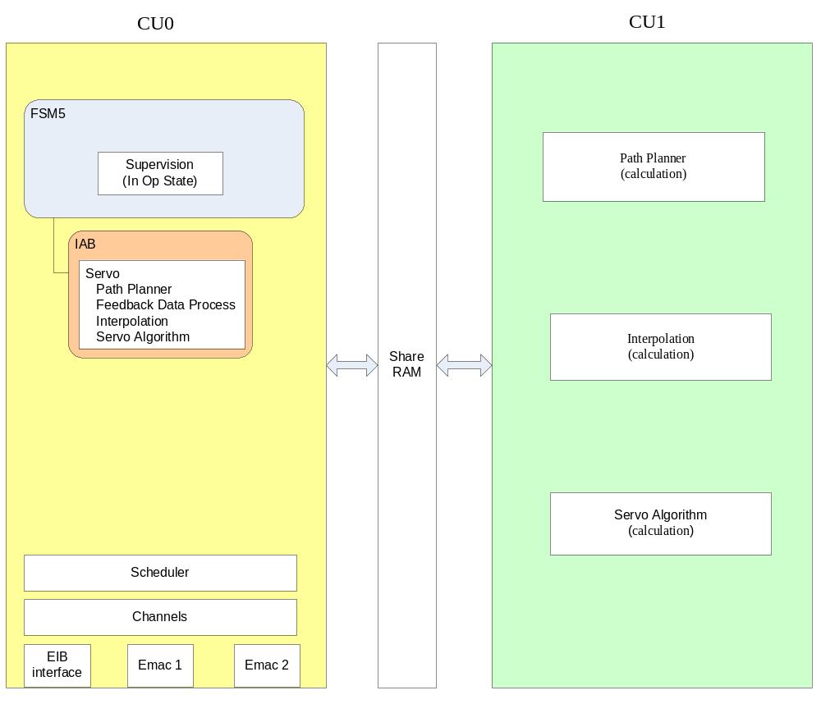
Fig 1 Design of System Structure
As shown in Fig 1, the FSM5 is present the servo system’s activity in CU0, the CU1 is used as a cooperation calculation unit of CU0, and the design works is as following:
- FSM5: Servo System’s activities (Boot, Init, PreOp, SafeOp and Op)
- IAB: Servo IAB
- Channels: EIB Interface, EMAC1 and EMAC2
- Scheduler: timing of the servo system
- Calculation Units: Path-Planner, Interpolation and Servo Algorithm

Servo FSM5
The Servo FSM5 is designed as following:
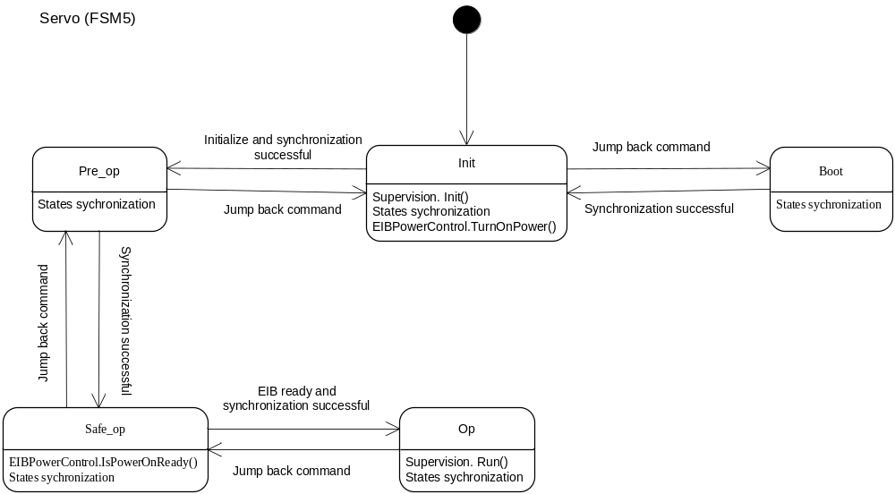
Fig 2 Design of Servo FSM5
As shown in Fig 2, following are the activities in servo FSM5’s states:
- EIB power management
- Supervision
- Synchronization

3.1 EIB Power Management Design

3.1.1 Data Structure Design
The data structure of EIB power management is designed as following:
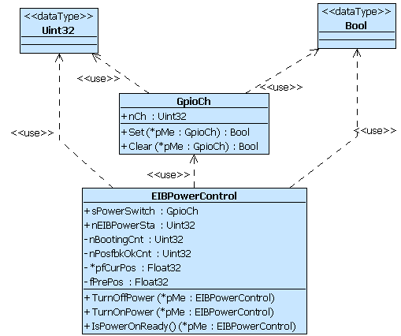
Fig 3 Data Structure of EIBPowerControl

3.1.2 Activity Design
The activity of TurnOffPower is designed as following:
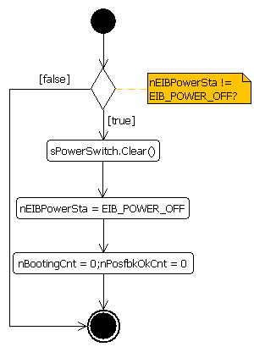
Fig 4 Activity of TurnOffPower

The activity of TurnOnPower is designed as following:
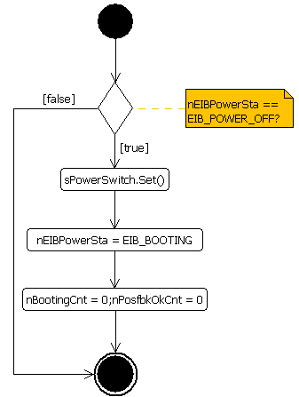
Fig 5 Activity of TurnOnPower
The activity of IsEIBPowerReady is designed as following:
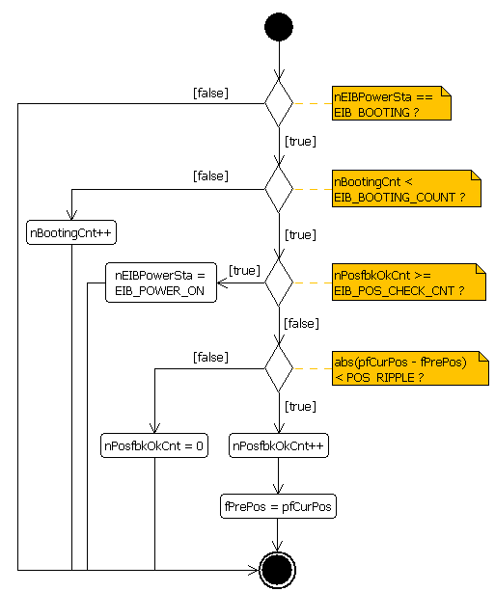
Fig 6 Activity of IsEIBPowerReady

3.2 Supervision Design

3.2.1 Data Structure Design
The data structure of Supervision is designed as following:
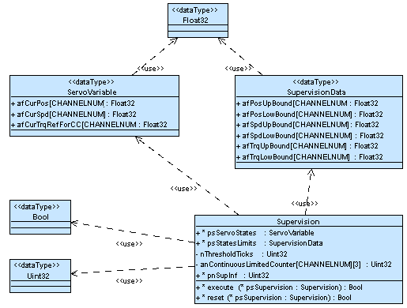
Fig 7 Data Structure of Supervision

3.2.2 Activity Design
The activity of Supervision is designed as following:
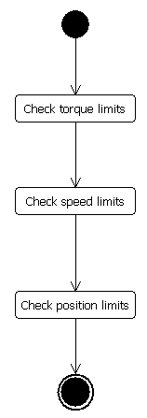
Fig 8 Activity of Supervision

3.3 Synchronization Design
This part will be provided by the template.

Servo IAB
The Servo IAB is designed as following:
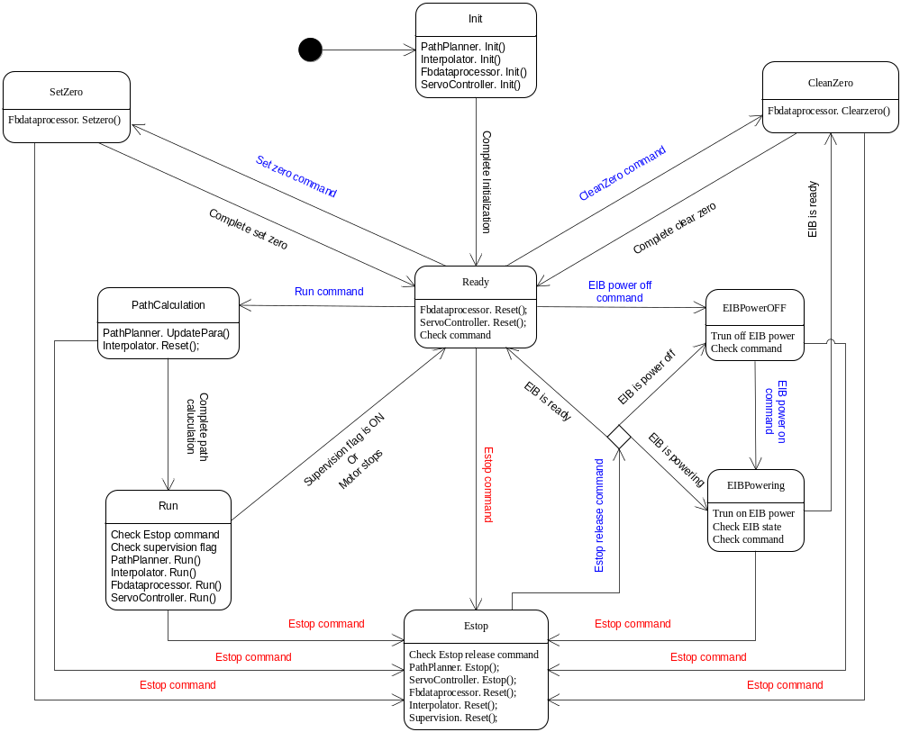
Fig 9 Design of Servo IAB
As shown in the Fig, following are activities in servo IAB:
- Feedback Data Process
- Path Planner
- Interpolation
- Servo Algorithm
The Feedback Data Process will be executed in the CU0, for other activities will be executed in CU1 as calculation units.

4.1 Feedback Data Process Design

4.1.1 Data Structure Design
The data structure of Feedback Data Process is designed as following:
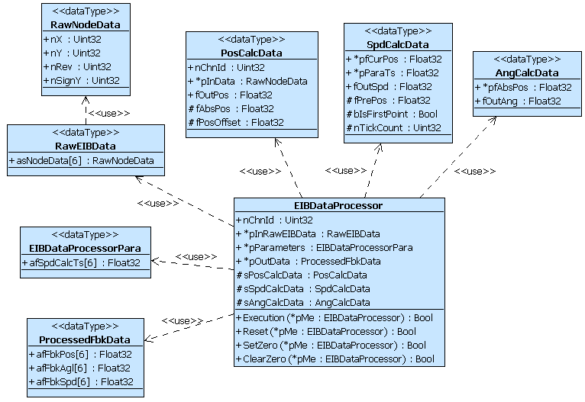
Fig 10 Data Structure of Feedback Data Process

4.1.2 Activity Design
The activity of Execution is designed as following:
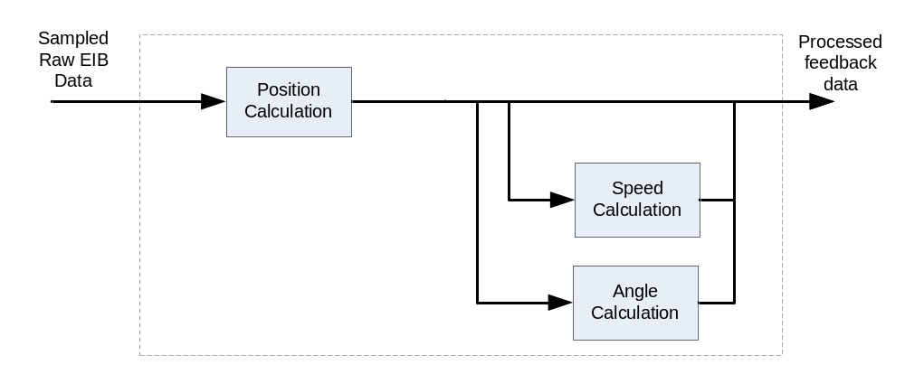
Fig 11 Activity of Execution
The activity of Position Calculation is designed as following:
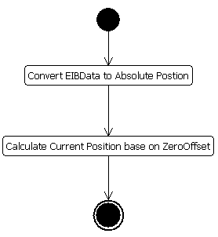
Fig 12 Activity of Position Calculation
The activity of Speed Calculation is designed as following:
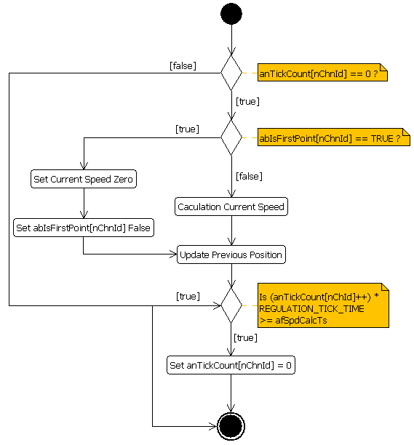
Fig 13 Activity of Speed Calculation
The activity of Angle Calculation is designed as following:
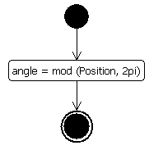
Fig 14 Activity of Angle Calculation

4.2 Path Planner Design

4.2.1 Data Structure Design
The data structure of Path Planner is designed as following:
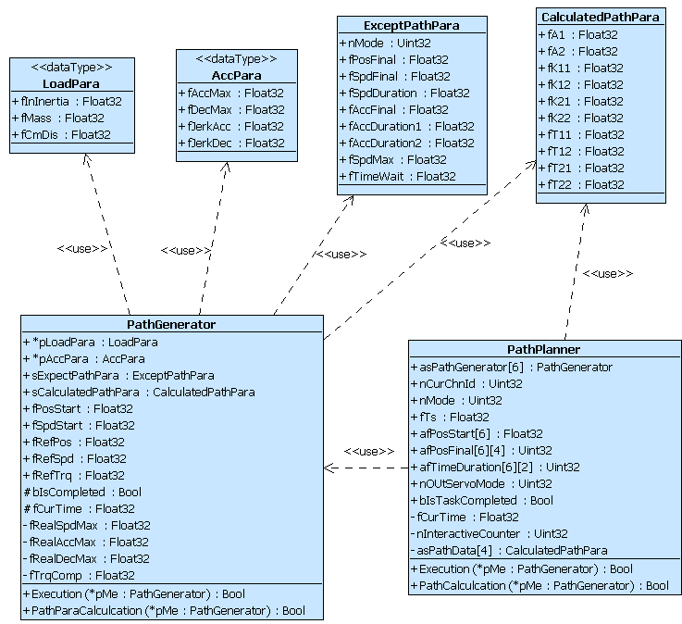
Fig 15 Data Structure of Path Planner

4.2.2 Activity Design
The activity of PathParaCalculation in the PathGenerator is designed as following:
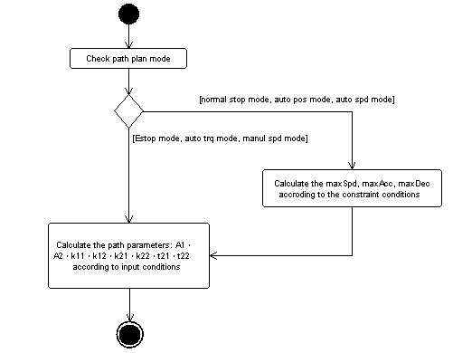
Fig 16 Activity of PathParaCalculation in PathGenerator
The activity of Execution in the PathGenerator is designed as following:
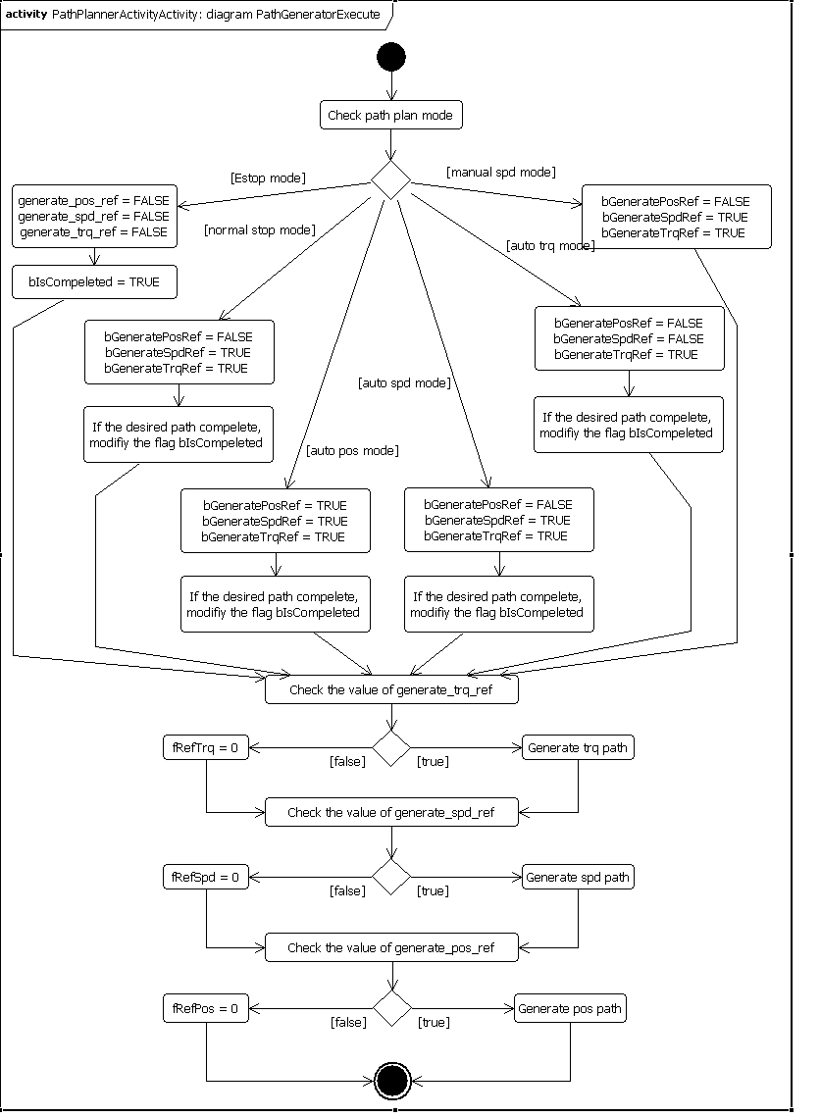
Fig 17 Activity of Execution in PathGenerator
The activity of PathCalculation in the PathPlanner is designed as following:
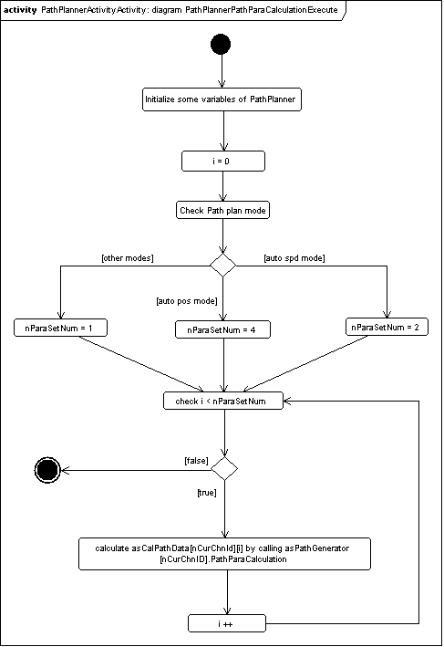
Fig 18 Activity of PathParaCalculation in PathPlanner
The activity of Execution in the PathPlanner is designed as following:
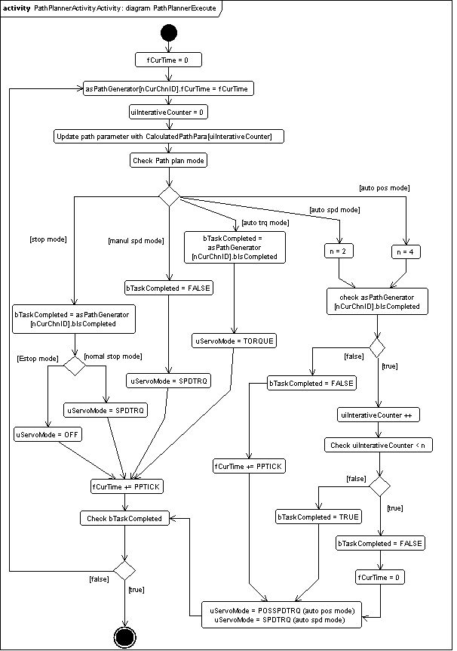
Fig 19 Activity of Execution in PathPlanner

4.3 Interpolation Design

4.3.1 Data Structure Design
The data structure of Interpolation is designed as following:
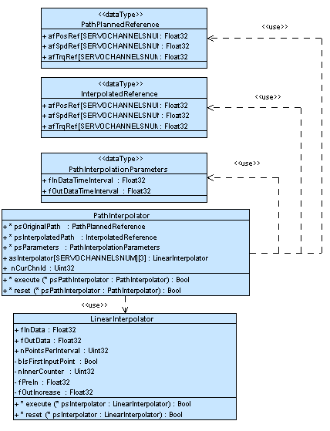
Fig 20 Data Structure of Interpolation

4.3.2 Activity Design
The Activity of Interpolation is designed as following:
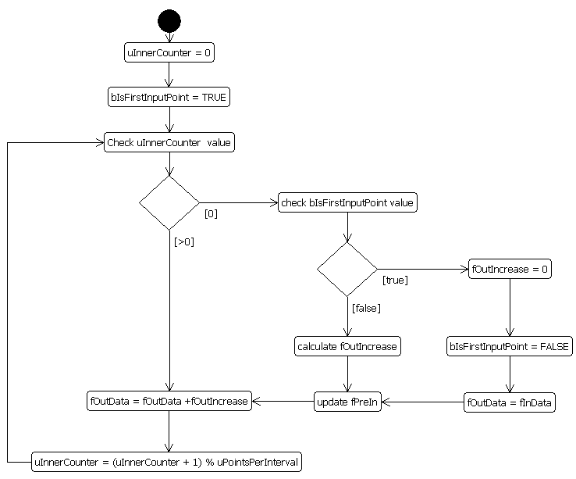
Fig 21 Activity of Interpolation

4.4 Servo Algorithm Design

4.4.1 Data Structure Design
The data structure of Servo Algorithm is designed as following:
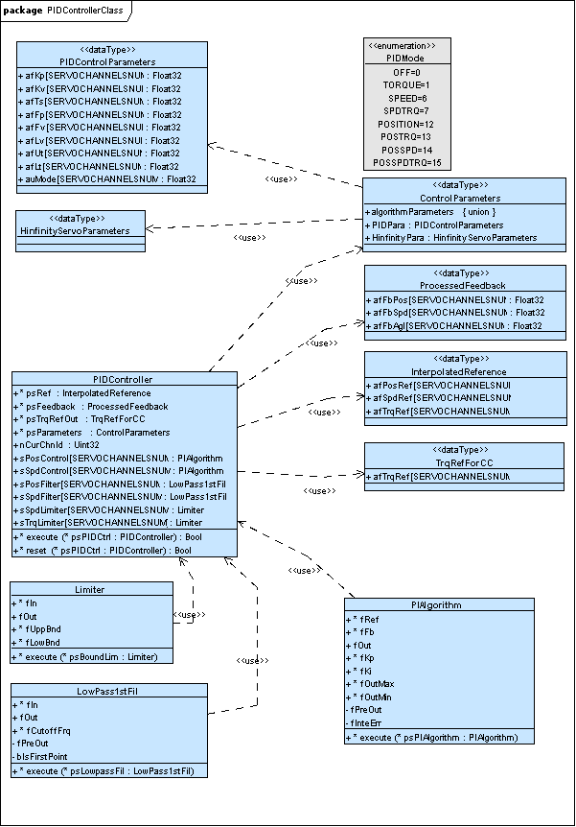
Fig 22 Data Structure of PID Controller

4.4.2 Activity Design
The Activity of Servo Algorithm is designed as following:
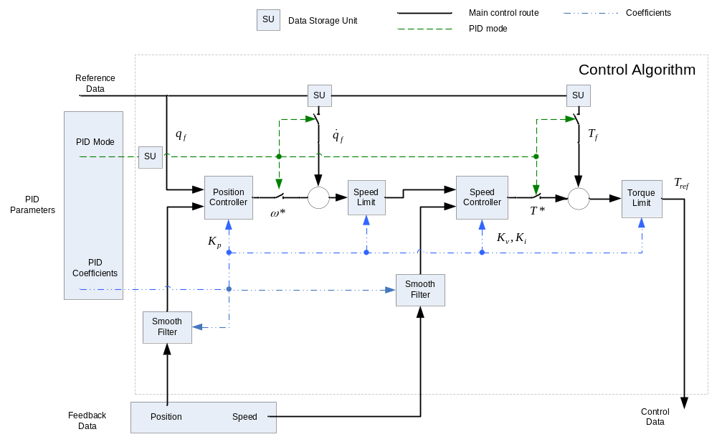
Fig 23 Activity of Servo Algorithm

The Activity of PI Algorithm, which is used in Position Controller and Speed Controller, is designed as following:
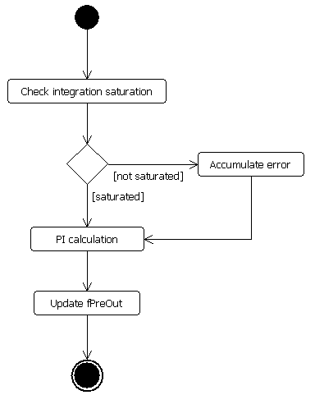
Fig 24 Activity of PI Algorithm

The activity of Filter Process is designed as following:
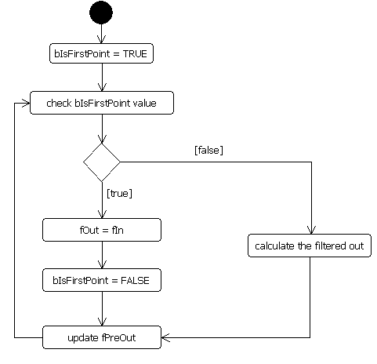
Fig 25 Activity of Filter Process
The activity of Limit Process is designed as following:
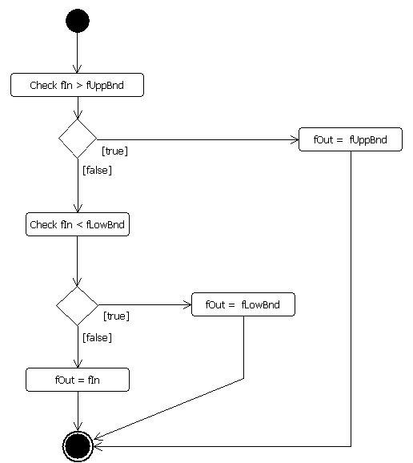
Fig 26 Activity of Limit Process

Channels
Following Channels are created for servo system:
- EIB Interface
  - Connect with EIB to get position feedback for servo control
  - Be activated/deactivated by the user
- EMAC1
  - Connect with Drive Board to send references, position information, commands and etc
  - Be activated/deactivated by the user
- EMAC2
  - Connect with Safety Board to exchange information with Comm board
  - Be activated/deactivated by the user

5.1 Ring Master Driver Design
This part will be provided together with the template.

5.2 EMAC Driver Design
This part will be provided together with the template.

Scheduler
Following are the activities scheduled every 63 us:
- EIB Interface Send start sample command if activated by the user
- EMAC1 Send Data if activated by the user
- EMAC2 Send Data if activated by the user
- Servo FSM Run (Servo IAB & FSM5)
- EMAC1 Receive Data if activated by the user
- EMAC2 Receive Data if activated by the user
- EIB Interface get sample data if activated by the user
For time-cost actions in the IAB, calculation units are designed to save computing power in the CU0, please reference to Calculation Units for details.

Calculation Units
The computing units are designed to save computer power in CU0, the computing units are in CU1 (reference to Design Overview):
- Path Planner
- Interpolation
- Servo Algorithm
The activities of calculation units in CU1 are designed as following:
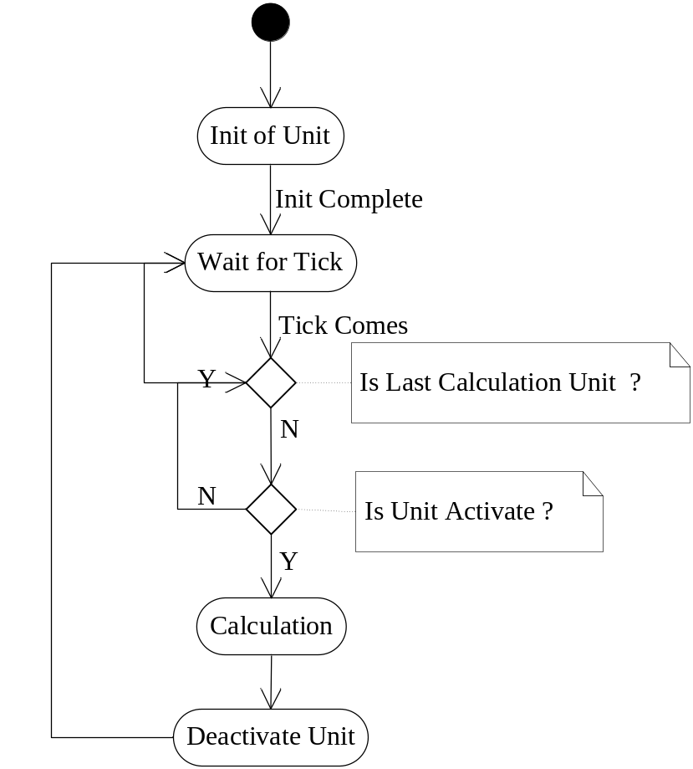
Fig 27 Activities of Calculation Units
As show in Figure, the calculation unit in the CU1 will be called if it is activated when tick comes, and then deactivate itself and wait for next tick comes. In the CU0 side, the application will activate the related calculation unit.

Path Planner Design

In

References
The following is a list of the documents in this report.

Ref. Number | Description
[1]
[2]
[3]

Revision
Rev. ind. | Page (P)  Chapt. (C) | Description | Date  Dept. /Init.
v0.1 | all | Draft | 2010-09-09  Robotics R&D Shanghai/Benson Ma, Andy Zhang

